Experiment 19:

Aim:

To establish Make Computer Lab in Cisco Packet Tracer.

Procedure:

STEP: 1 Take switch

STEP: 2 Link that with the 5pcs with first and 5pcs with second and 5pcs with third pcs.

STEP: 3 Connect that router and switches with server and pc with connection.

STEP: 4 If message send correctly, you got successful otherwise recheck the connections.

STEP:5 Connect the computer lab.

Step 1:

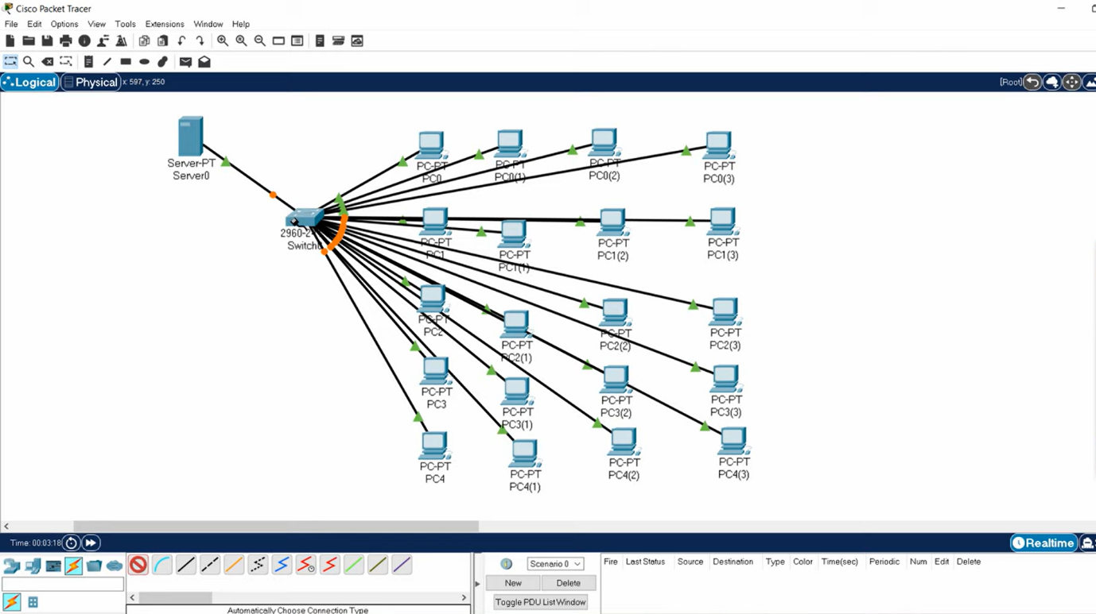

Step 2:

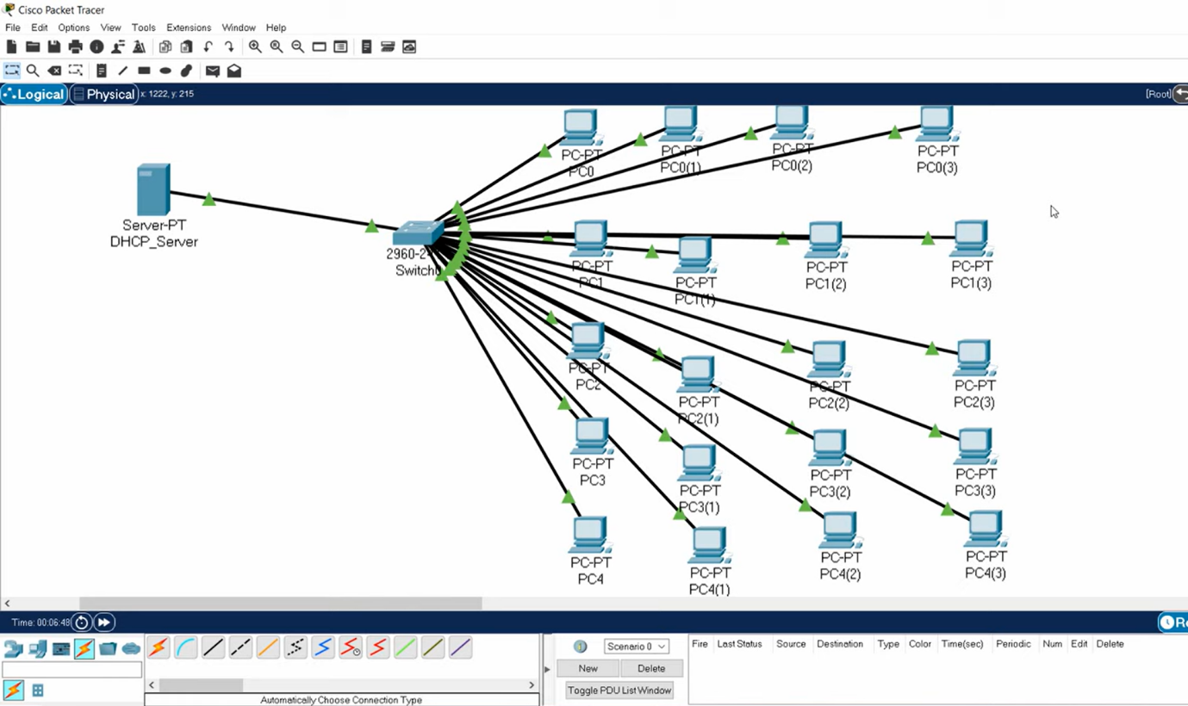

Result:

To establish Make Computer Lab in Cisco Packet Tracer is verified successfully.